Howbrite Solutions, Inc. 800 505-MATH
P.O. Box 880 320 286-2597
Cokato, MN 55321 fax 320 286-6338
www.howbrite.com mathline@howbrite.com
03/28/16

To Whom It May Concern;

This letter is to inform you that we hold the trademark, patents, and copyrights of all MathLine materials & products which includes RekenMathLine. The patent numbers are as follows: 5,149,269 Sep’t. 22, 1992; Re.34,498 Jan. 4,1994, reissue; 5,334,026 Aug. 2, 1994, reissue. We are the sole manufacturer of all MathLine products. Patent pending for iMathLine Core Math Teacher and RekenMathLine.

We are sole source for all MathLine Products which include (but not limited to):
-Student31, Student100, Junior10, & Junior20 MathLine models
-Jumbo10, Integer models, Teacher31, & Teacher100 MathLine models
-MathLine Whiteboard models and all models carrying the MathLine name
-All MathLine Videos, All MathLine Class Sets, MathLine Educational Series which include Teacher Guides, Training DVD’s, and Student Activity Books
-All products under the MathLine Learner Series
-All MathLine Web Materials (A, B, B2, C, C2, D, E, F, Integer) and MathLine Web Tutor
-iMathLine and iMathLine Core Math Teacher and MathLine All-in-One digital tools.
-All RekenMathLine products including RekenMathLine, RekenMathLine+, RekenMathLine100, RekenMathLine 5x20, and RekenMathLine 6x20.

We are the sole trainers of MathLine Concept-Building Workshops and all professional development of MathLine. Therefore, supplemental purchases that include teacher training are also sole source.

Sincerely,

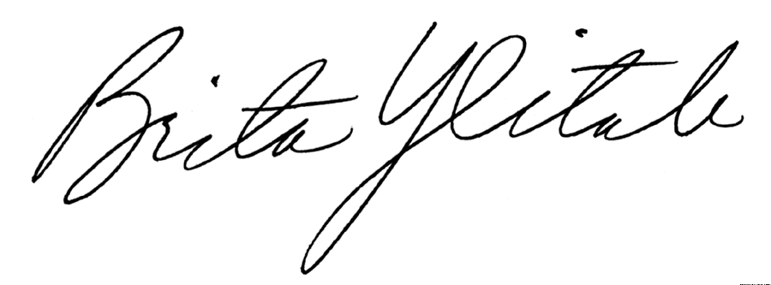

Brita Ylitalo
President, Howbrite Solutions, Inc.

